# **Department of Computer Science and Engineering Islamic University of Technology (IUT)** A subsidiary organ of OIC

# **Lab Report 1**

# CSE 4512 : Computer Networks Lab

## 

## **Name:** Abdullah **Student ID:** 200041126 **Section:** 1B **Semester:** 5th **Academic Year:** 2022-2023

**Date of Submission:** 09-08-2023

### **Title:** Familiarizing with the Packet Tracer environment

### **Objectives**:

1. Download and install Cisco Packet Tracer
2. Learn about use-cases of Cisco Packet Tracer
3. Get acquainted with different components of Cisco Packet Tracer environment
4. Understand how to operate Cisco Packet Tracer
5. Implement a small network with switches

**Introduction:**

Cisco Packet Tracer, developed by Cisco Systems, is a virtual network simulation tool with diverse use-cases. Primarily aimed at education, it facilitates learning and practical application of networking concepts. It serves as a cornerstone in:

1. **Education**: Widely adopted in academic settings, Packet Tracer enables students to grasp networking intricacies by constructing and manipulating virtual network environments.
2. **Certification Prep**: Aspiring network professionals utilize Packet Tracer to hone skills needed for certification exams like CCNA, offering a risk-free platform for hands-on practice.
3. **Design and Testing**: Engineers can prototype and assess network designs before implementation, aiding in identifying potential bottlenecks or errors.
4. **Demonstrations**: Instructors and trainers use it to visually elucidate networking principles, enhancing comprehension and engagement.
5. **Remote Learning**: Particularly valuable for remote learning scenarios, Packet Tracer allows learners to engage in practical networking exercises from any location.
6. **Protocol Exploration**: Users can experiment with diverse protocols, such as routing, IP addressing, and security mechanisms, gaining deeper insights into their functions.
7. **Troubleshooting**: Packet Tracer provides a controlled environment to simulate and resolve network issues, bolstering practical troubleshooting skills.
8. **Virtual Lab Replacement**: For those without access to physical networking equipment, Packet Tracer offers a cost-effective substitute for setting up a physical lab.

In essence, Cisco Packet Tracer stands as an indispensable tool for students, educators, and professionals, offering a safe and efficient means to learn, practice, and refine networking expertise.

### **Interface of Cisco Packet Tracer:**

* **Menu Bar:**



* **Main Tool Bar:**

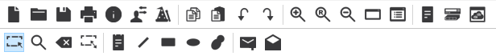

* **Logical/Physical Workspace and Navigation Bar:**



* **Realtime/Simulation Bar:**

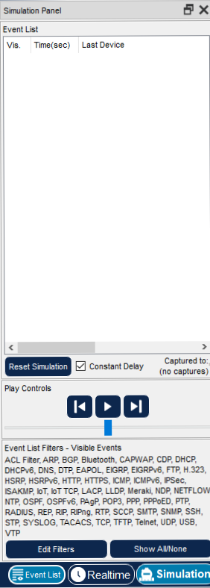

* **Network Component Box:**



* **Device-type Selection Box:**



* **Device-specific Selection Box:**

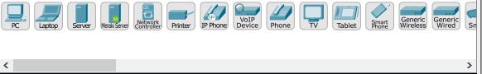

* **User Created Packet Window:**



### **Key Features of Cisco Packet Tracer:**

### 1. Packet Tracer provides a wide array of virtual networking devices, including routers, switches, PCs, servers, and phones, allowing users to create complex network topologies.

### 2. Devices in Packet Tracer behave like their real-world counterparts, responding to configurations and commands as they would in an actual network environment.

### 3. Users can interact directly with devices, configure settings, and observe the outcomes in real time, fostering hands-on learning and experimentation.

### 4. Packet Tracer supports multi-user collaboration, enabling users to work together on the same simulation, facilitating teamwork and knowledge sharing.

### 5. Instructors can design assessments and activities using Packet Tracer, helping to evaluate students' networking skills and understanding in a controlled virtual environment.

**Picture and explanation of the implementation:**

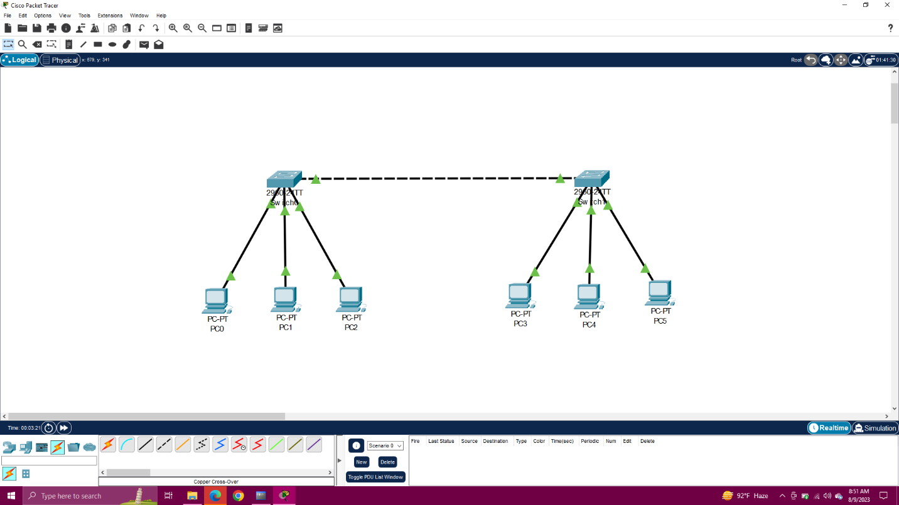

The lab task involved setting up a network with 6 PCs and 2 switches. Three PCs were connected to each switch using copper straight-through wires, suitable for connecting different device types. The switches were interlinked using copper cross-over wires, designed for connecting similar device types. To establish connectivity, each PC was assigned an IP address and subnet mask.

**References:**

* <https://subscription.packtpub.com/book/cloud-and-networking/9781782170426/1/ch01lvl1sec05/interface-overview>